Table of Contents
1. ABSTRACT 3
2. INTRODUCTION 3
2.1. Objectives of the study 4
2.2. Discussion about dataset 4
3. Literature review 4
3.1. Data management and Visualization in sales analytics process 4
3.2. Tools and Techniques in R studio for data analysis 5
4. DATA EXPLORATION AND CLEANING 5
5. DATA PREPARATION. 8
6. DATA VISUALISATION 9
7. Results 16
8. Conclusion 17
9. PROFESSIONAL, ETHICAL AND LEGAL CONSIDERSATIONS 17
10. Future work 18
References 19

ABSTRACT
Available on Kaggle, the Europe Bike Store Sales dataset provides a wealth of information for critical investigation of data management and visualization within the framework of retail sales. This dataset provides a broad foundation for study in data science and business analytics by combining a variety of variables, such as date, consumer demographics, and specific product information. This dataset is important because it can provide deep insights into the changing dynamics of a bicycle store's business activities in different parts of Europe. The academic report addresses organizing, cleaning, and preparing the dataset for analysis by using strong data management approaches. Missing numbers are filled in and patterns in the data are found by carefully examining the data. By laying the foundation for further analyses, this step guarantees the accuracy and consistency of the results. To show that one is capable of managing complicated datasets, a thorough explanation of the use of sophisticated data transformation and manipulation techniques is provided, all within the framework of the R programming language. The main focus of the academic report is on utilising R to capitalize on the dataset for insightful visualisation. The study shows how to make informative graphs and charts that clarify sales patterns, consumer behaviours, and how products perform through a series of trials. These visual aids make complex data structures easier to understand for all parties involved and promote well-informed decision-making. A number of R programs, like ggplot2, tidyverse, dplyr etc are used to create eye-catching graphics that improve the data's ability to communicate. A thorough discussion of the outcomes gained through data management and visualization approaches is presented, highlighting significant discoveries and revelations from the Europe Bike Store Sales dataset. The importance of these methods for obtaining useful information from huge and varied datasets is emphasized in the report's conclusion, which also identifies directions for future study to promote the ongoing investigation of data science approaches in business analytics. All things considered, this academic research adds to the developing field of data management and visualization by providing both academics and professionals with useful approaches and insights.

INTRODUCTION
With the help of business intelligence and analytics, one can examine the complex dynamics of the European bicycle markets as Chen, Chiang, and Storey (2012) discuss in "Business Intelligence and Analytics: From Big Data to Big Impact." The Europe Bike Store Sales dataset, which comes from Kaggle, reveals an extensive variety of retail data. This dataset provides a thorough picture of the retail environment by capturing transactional details, consumer characteristics, and product details. Predicting seasonal and regional changes in bike demand within this dataset requires an understanding of its temporal and spatial characteristics. In keeping with the ideas covered by Verhoef, Kannan, and Inman (2015), this investigation looks into the location and timing of particular bike demand in order to inform inventory stocking choices that lead to enhanced shop operating. We may uncover insights from the data that go beyond conventional multi-channel commerce, focusing on multichannel strategies as we adjust to the changing environment. In addition, the depth of the dataset is critical in determining beneficial models and sizes, which is consistent with the customer-centric strategy that Fader, Hardie, and Lee (2005) advise. By using statistical models to analyze the sales data, it is possible to identify particular bike models and sizes that have strong profit margins and high sales. This in-depth knowledge serves as a roadmap for purchasing choices and thoughtful product placement in stores, forming a retail plan that boosts sales and profitability. The Europe Bike Store Sales dataset appeared as a wealth of information that may transform retail strategy as we work our way through the various layers of data research and experimentation. With its combination of scholarly detail and real-world applicability, this investigation hopes to advance both retail analytics and the conversation about using data to make well-informed decisions in the retail industry.
Link of the dataset: Europe Bike Store Sales (kaggle.com)

Objectives of the study

The study’s main goal is to analyse the sales data of Europe bike store in different regions on year to year basis and gain insights and provide recommendations to the organisation based on the insights about which area they need to focus in order to improve the sales of the company. The second main purpose of the study is to utilise the data and visualize to gain insights and focus on various aspects in order to improve the overall profit of the organisation.

Discussion about dataset

This report makes use of “Europe bike store sales” dataset, which is obtained from Kaggle an open-source platform that is well-known for having wide range of datasets. The dataset contains 113,036 rows and 18 columns, each represents a unique attribute. The variables of the data are Date, Day, Month, Year, Customer Age, Age Group, Customer Gender, Country, State, Product Category, Subcategory, Product, Order Quantity, Unit Cost, Unit Price, Profit, Cost, Revenue.

Literature review

Data management and Visualization in sales analytics process

The complementary nature of data management and visualization in the field of sales analytics is demonstrated in significant research conducted by Fergurson (2020), Brea (2014), and Habel et al. (2023). Brea's examination of "Proven Techniques and Powerful Applications" highlights the fundamental function of techniques in the process of making decisions, implying that well-managed data is essential. Fergurson's "Data-Driven Decision Making via Sales Analytics" focuses on how data management is essential to selecting high-quality datasets and clearly illustrates how data can transform decisions. Furthermore, it is advised that using visualization approaches is crucial to communicating complicated insights to decision-makers. The study "Effective Implementation of Predictive Sales Analytics" by Habel et al. emphasizes how important it is to have precise and well-managed data for training predictive models. Although their work does not directly deal with visualization, it does highlight how crucial high-quality data is to predictive analytics. In order to fully explore the potential benefits of data-driven decision-making in sales, a complete strategy that effectively combines these components is necessary, as these studies collectively highlight the symbiotic relationship between robust data management, effective visualization, and the overall efficacy of sales analytics (Brea, 2014; Fergurson, 2020; Habel et al., 2023).

Tools and Techniques in R studio for data analysis

The effectiveness of R Studio, an integrated development environment for the R programming language, in data analysis has drawn a lot of attention from the literature. "R for Data Science" by Wickham and Grolemund (2016), a thorough manual on fundamental R data science techniques, is a foundational work in this topic. The authors demonstrate R Studio's ability, emphasizing its essential role in data manipulation, visualization, and exploratory data analysis through influential packages such as ggplot2 and dplyr. Chang et al.'s (2021) "Shiny" package, which presents a web application framework for R, is another important contribution. With the help of this package, analysts can enhance R Studio's interactive features by developing dynamic web applications that highlight their analyses and visualizations. Kuhn's (2008) analysis of the "caret" package reveals R Studio's ability to create predictive models quickly and effectively. The caret package improves R Studio's predictive analytics capabilities by streamlining the model training and evaluation procedures. The work Yihui Xie (2015) did on "Dynamic Documents with R and knitr" highlights how special R Studio is at integrating code and results into documents in a way that makes analyses and reports repeatable. All things considered, these contributions to the literature support R Studio's reputation as a flexible and efficient environment for a wide range of data analytic applications. The combination of R Studio's complicated packages and frameworks with its straightforward user interface makes it the tool of choice for data scientists and analysts working in a variety of data science and analytical domains.

DATA EXPLORATION AND CLEANING
The first stage of data analysis is data exploration. Examining and comprehending the properties, patterns, and connections within the dataset is a crucial step in the data analysis process known as data exploration. Within the Europe Bike Store Sales dataset on Kaggle, data exploration is essential for revealing patterns and directing further analytical work. Finding emerging trends and patterns in the dataset is a crucial part of data exploration. Researchers can identify trends that could affect company actions by looking at variables like sales, customer demographics, and product categories. These data can also reveal seasonality and regional preferences. For example, employing R tools such as ggplot2 to visualize yearly sales patterns across several areas can offer a thorough understanding of the temporal and spatial dynamics of the dataset (Wickham, 2016). Furthermore, outliers and unusual patterns can be found by data exploration. Variations in the bike sales data may point to unusual occurrences or mistakes in the dataset, requiring additional research and data cleaning. Employing techniques like box plots or scatter plots can aid in finding such abnormalities and assuring data quality. Another important component of data research is figuring out how different variables, including client age, gender, and product categories, are distributed. Product placement in stores, inventory control, and targeted marketing methods can all benefit from this knowledge. The distribution of categorical variables can be successfully communicated by using R visuals like as pie charts and bar charts (Chang et al., 2021). Data exploration is a continuous process that informs further analysis and decision-making, rather than just being a first step. It enables analysts to solve problems with data quality, discover important insights, and lay the groundwork for more in-depth investigations.

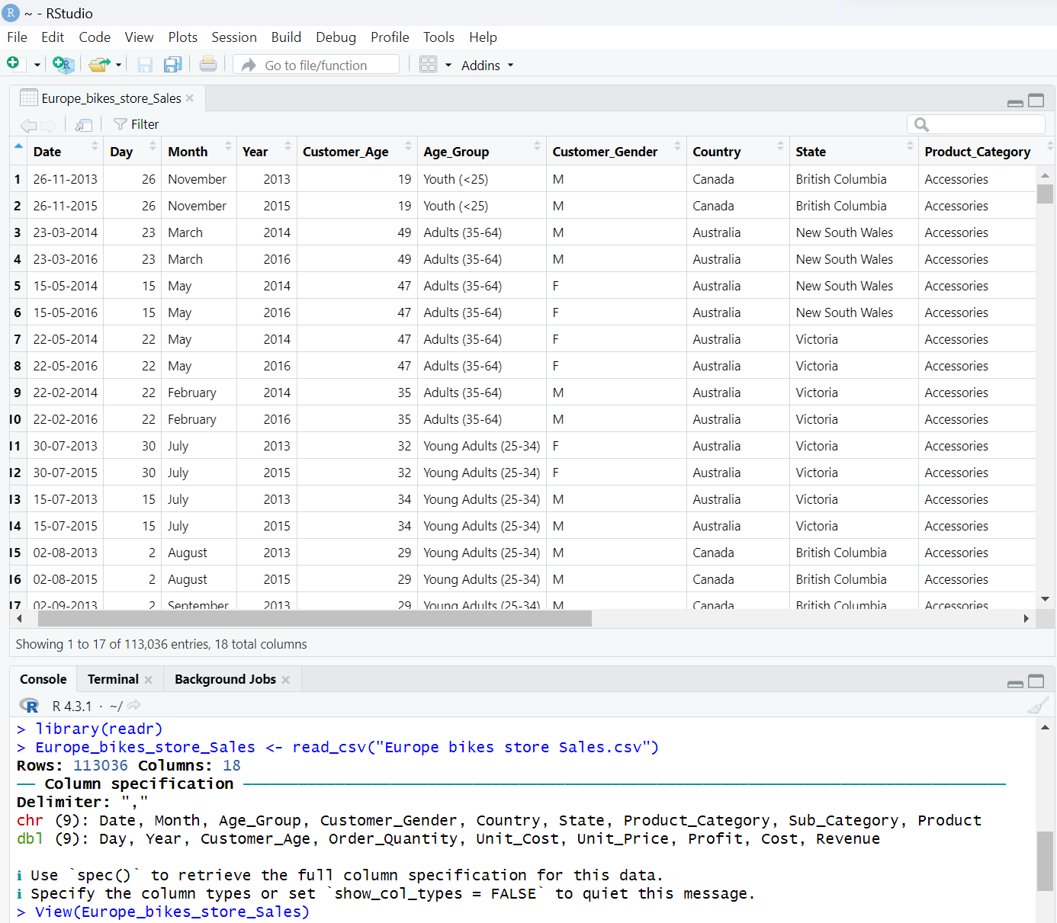
(source: acquired from R studio)
The above given output describes the importing of data to r studio using read_csv code as the dataset is stored in .csv format

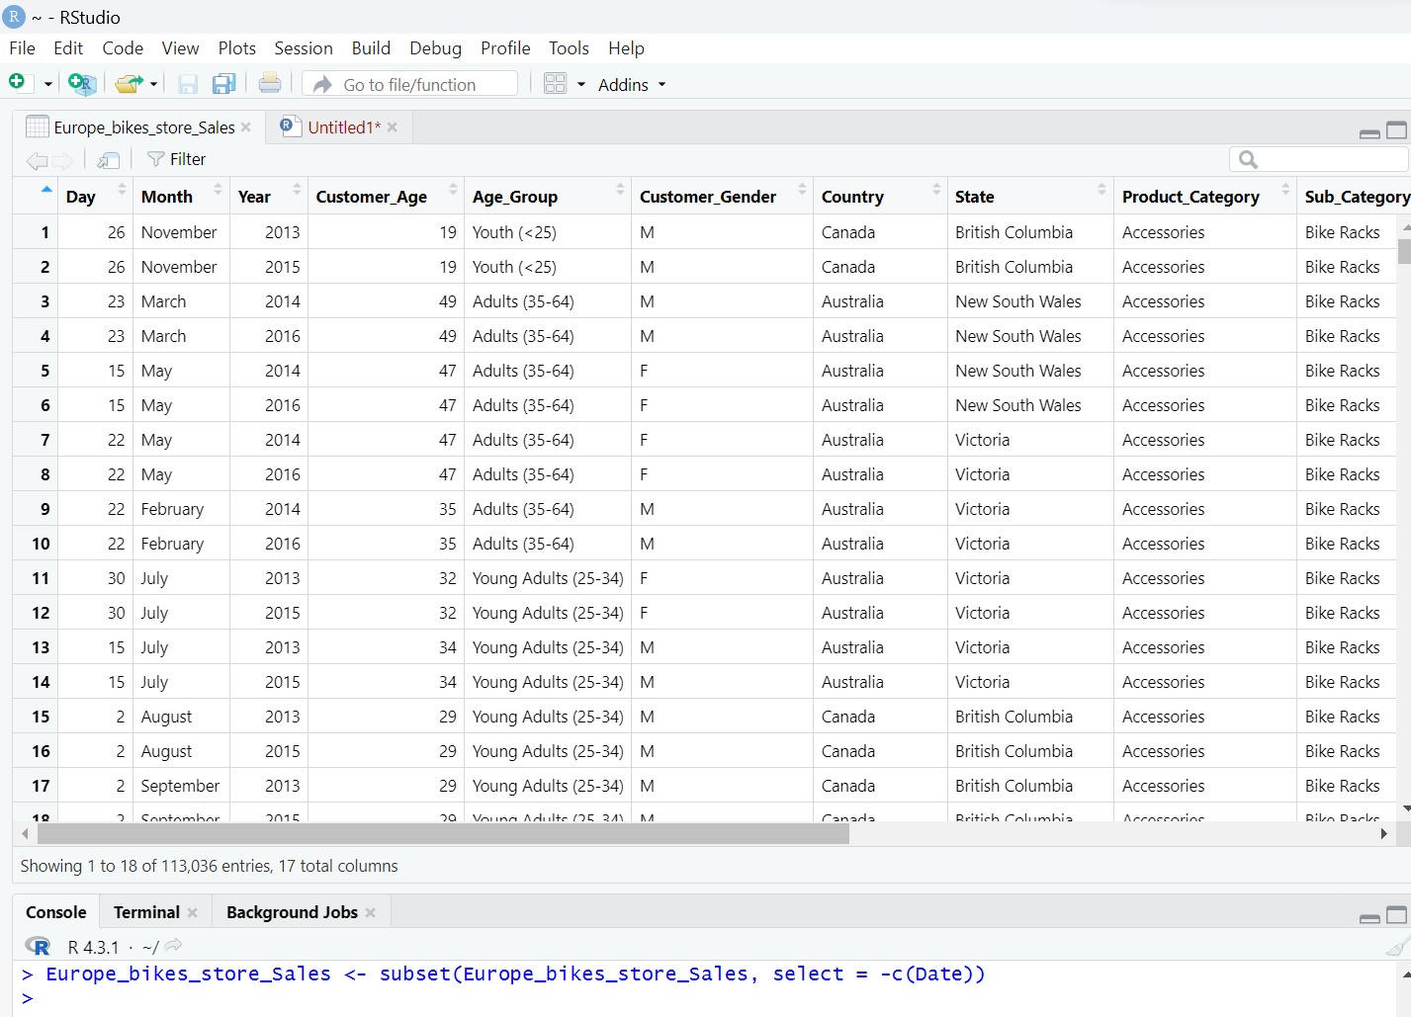
We cleaned the data by removing “Date” from the dataset as we already had separate Day Month and Year column.

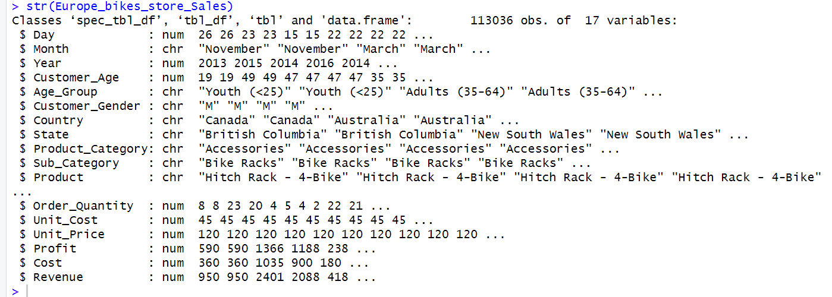

The above summary statistics after cleaning the data indicates that there are 113036 observations and 17 variables and also display all the variables this dataset contains. Mainly this summary helps us to get a brief overview and its contents of the dataset at one place.

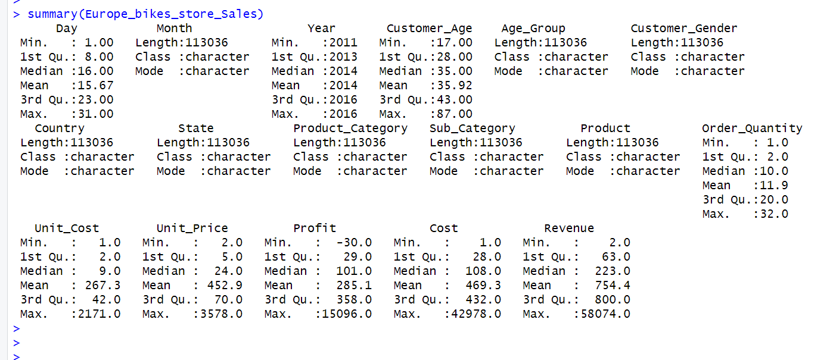

The above summary statistics gives a brief description of the Europe Bike Store Sales dataset's important figures and traits can be obtained by doing so. It provides information on data distribution, central tendencies, and possible abnormalities, laying the groundwork for making well-informed decisions during later stages of data analysis.

DATA PREPARATION.

In relation to R programming, preparing the data refers to transforming unprocessed data into a form that can be analyzed. Ensuring data correctness, completeness, and consistency requires this method. Effective data visualization and modeling are made possible by well-prepared and ordered datasets, as highlighted by Hadley Wickham in his seminal work "Data analysis" (2016). Essential components of data preparation in R include activities like encoding categorizing data, normalizing variables, and handling missing values. Furthermore, good data preparation increases the overall success of data-driven projects and improves the dependability of analytical results. Some works that emphasize the importance of careful data preparation are Dasu and Johnson's "Exploratory Data Mining and Data Cleaning" (2003).

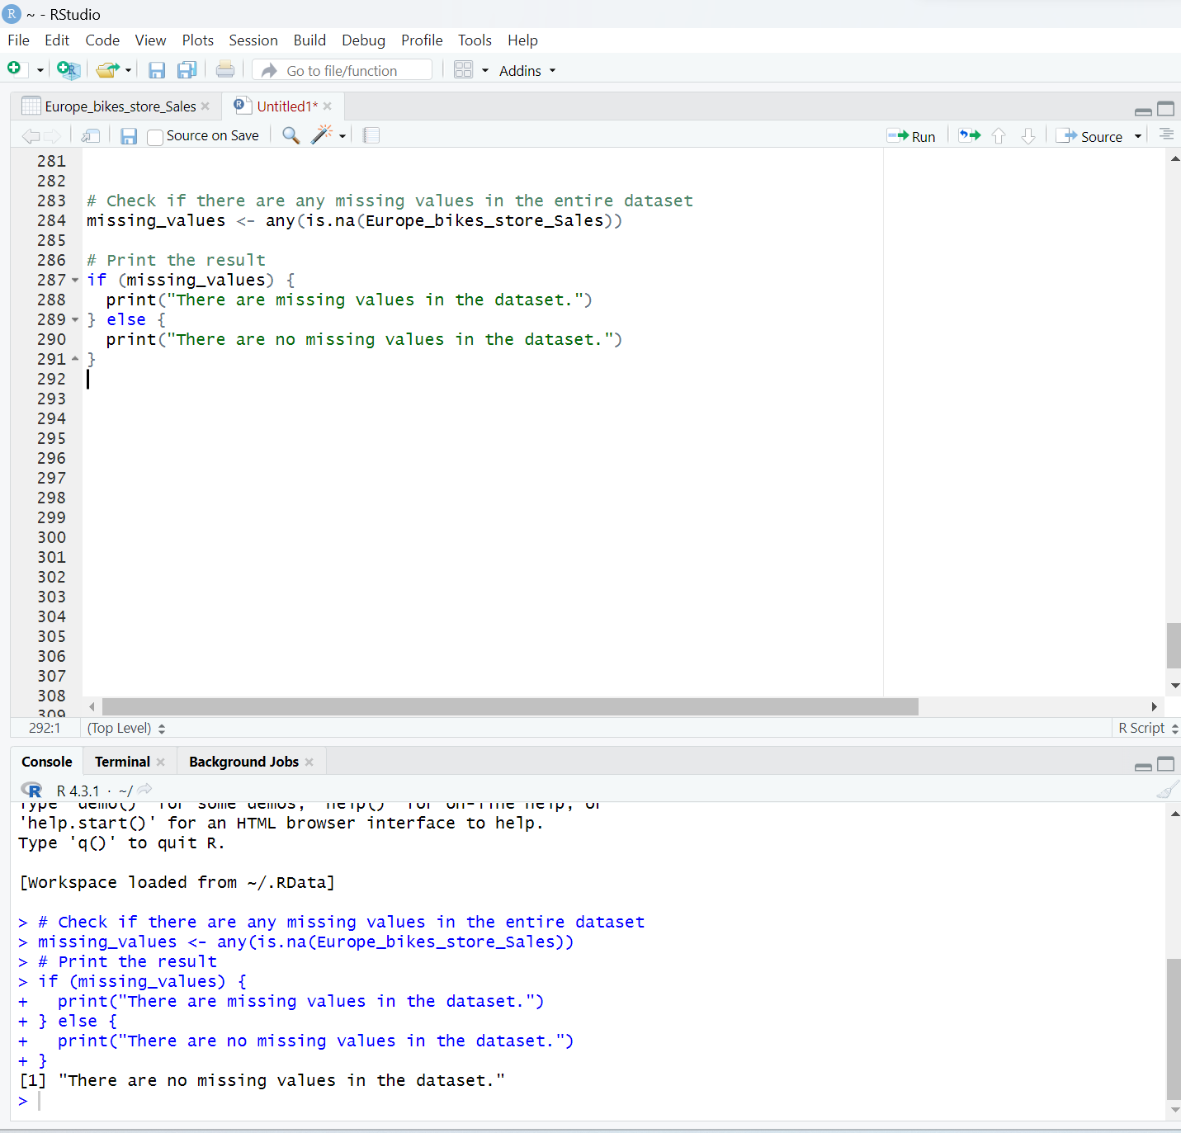

This result interprets that there are no missing values in the dataset. In order to preserve data authenticity and quality in academic research, it is essential to look for missing values. A study's results may be affected by missing data, which can also introduce biases and alter statistical metrics. Closing gaps guarantees the validity of statistical analysis results, improves reproducibility, and increases transparency.
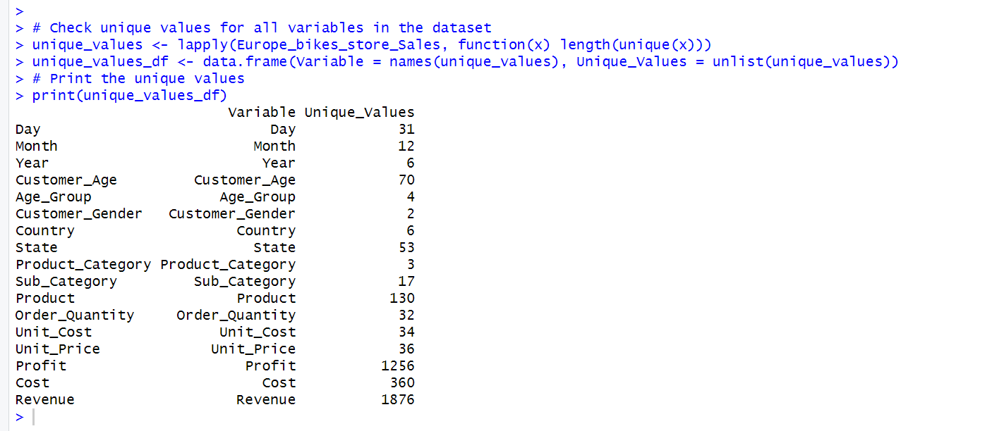

The above output indicates the number of unique values within each variable based on dataset. In order to detect errors, inconsistencies, and possible biases, it is essential for data quality assurance to verify unique values in R datasets. By addressing abnormalities, it helps clean up data, guarantees reliable analysis, and offers insights into variable distributions. Investigating unique values is essential for clarifying research topics, comprehending the properties of data, and preserving the accuracy of statistical studies.

DATA VISUALISATION

Data visualisation is an important aspect of data analysis because complex information can be represented in a more understandable and accessible manner to enable faster interpretation. Tufte 2001 states that good visual displays make it easier to understand quantitative information. It enables analysts to determine patterns, trends and relationships in the data. Heer and Shneiderman (2012) demonstrate that an interactive visualization helps support dynamic exploration as it let the users discover insights by interacting with data. Visualization plays a key role in exploratory data analysis as it assists analysts to iteratively analyze datasets and arrive at informed decisions. For the most part, data visualization is a powerful tool in communication because it helps stakeholders understand patterns easily and make decisions from an evidence-based perspective.

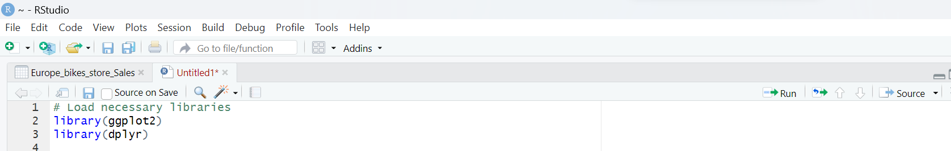

To begin the process of visualizing we first loaded the necessary libraries such as “ggplot2” and “dplyr” R programming requires the loading of libraries in order to utilize pre-built functions and tools for particular tasks. R's functionality can be expanded with the help of libraries, which save time and effort by removing the need to develop individual functions for common tasks.
YEARLY SALES TREND BY REGION

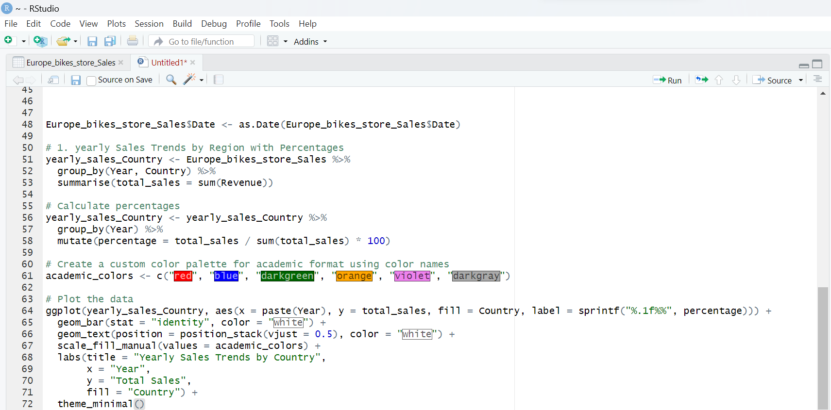
The above code helps to visualize the data in yearly sales based on different regions with details in percentage

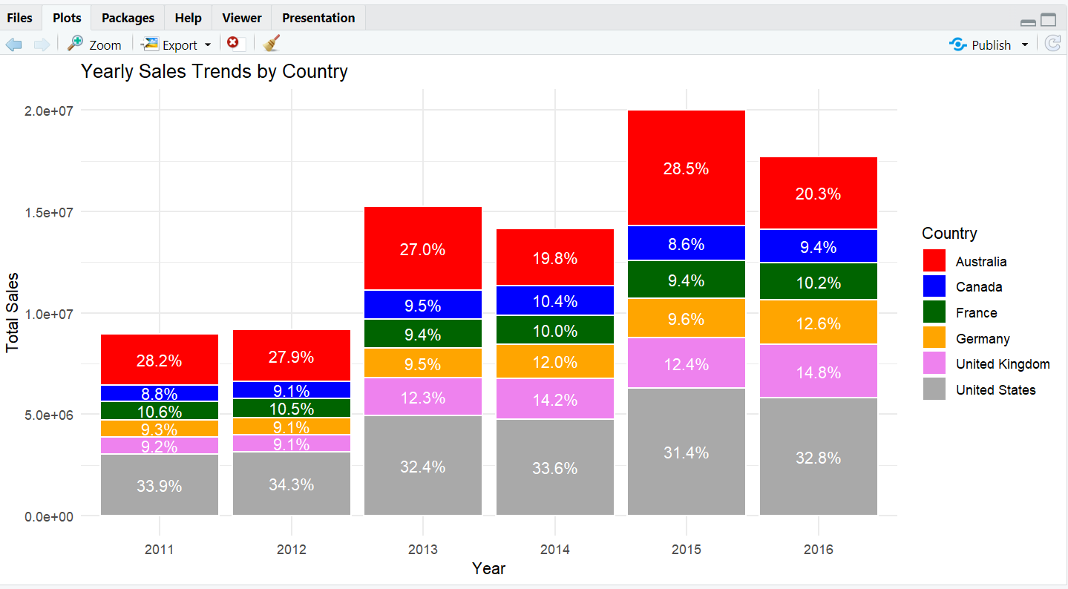

The graph illustrates yearly sales trends by country on the X axis we have years and on Y axis we have total sales. We can clearly interpret that their was a major drop in the total sales of australlia as it fell down from 28.5 in 2015 to 20.3 in 2016. So we need to focus more on australlia region and comeup with better promotional and discounts in order to increase the sales in that region.
Profitable models
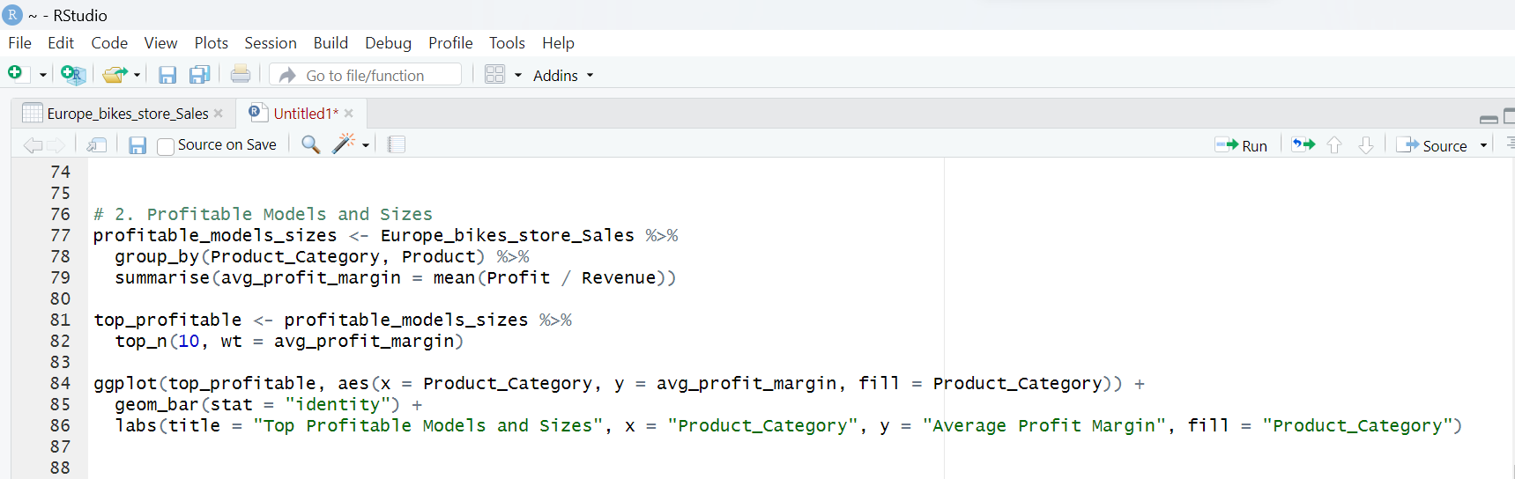
The above code helps to visualize the data of product categories and average profit margin.

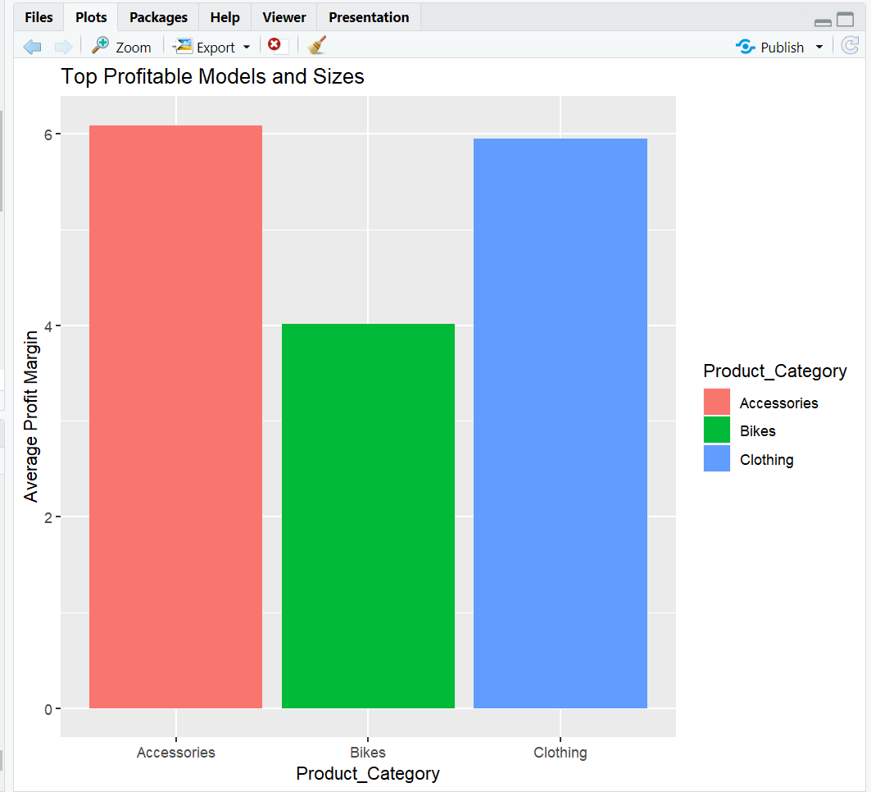

The above bar chart indicates top profitable categories, on the X axis we have product categories and on the Y axis we have average profit margin. We clearly get insight that bikes have the lowest average profit margin compared to other categories and we need to focus more on bikes. We must reduce the cost of the product in order to increase the profit margin.

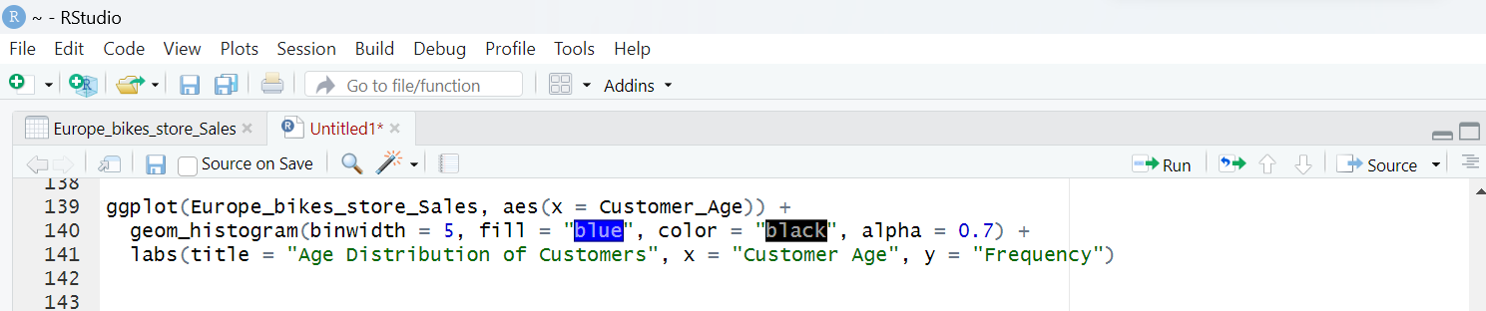
The above code helps us to get visualisation of distribution of age of customers

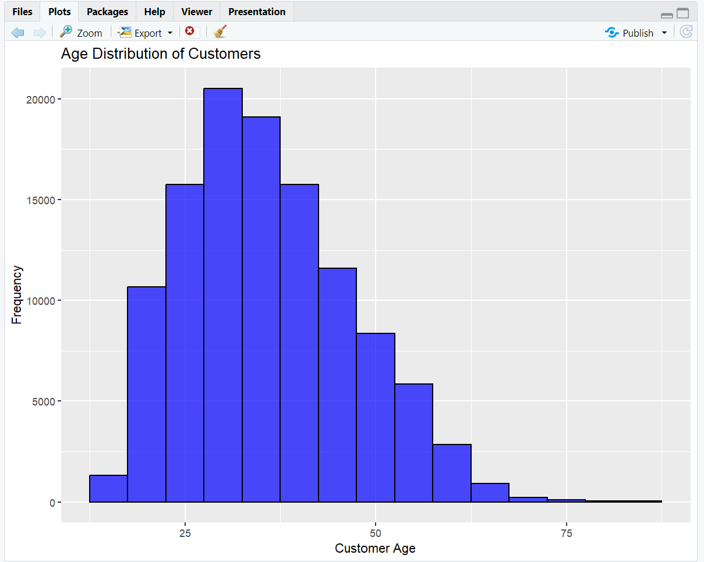

The above graph represents the age distribution of customers, on the X axis we have customer age and on Y axis we have frequency. The graph helps us to gain insight that the majority of the customers are from age group of approximately 20 years to 35 years so we need to focus more of our promotional activities on this age group to increase the sales and eventually profit further.

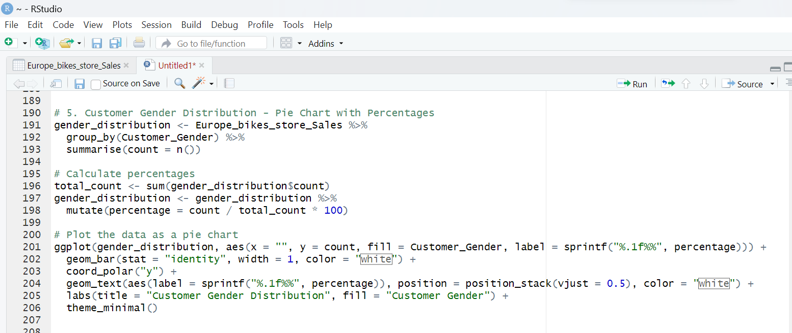
The above code help us to visualise the gender distribution of customers within the data with percentages.

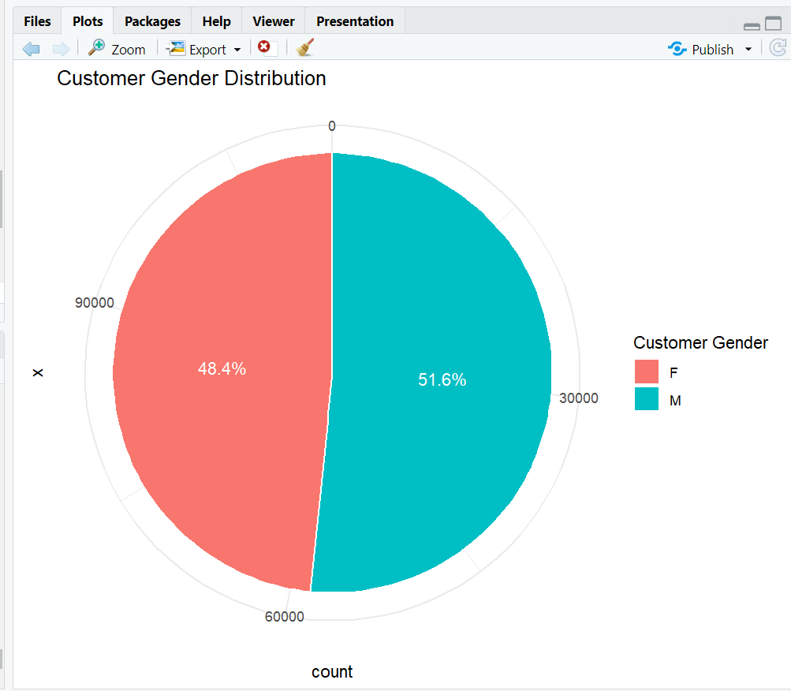

The above pie chart indicates that the turnout of male customers are slightly more than that of female. So we can focus more on male products to increase the sales.
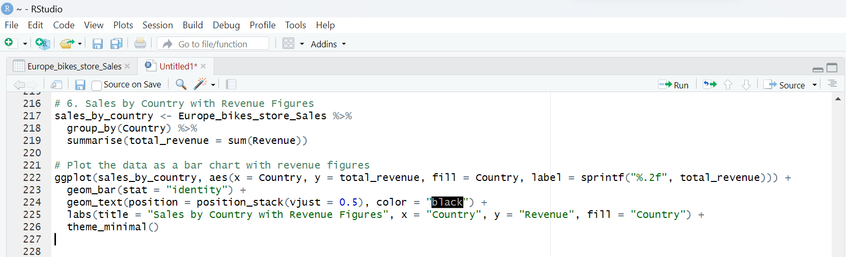
The above code help us to visualise the sales based on different countries with revenue figures.

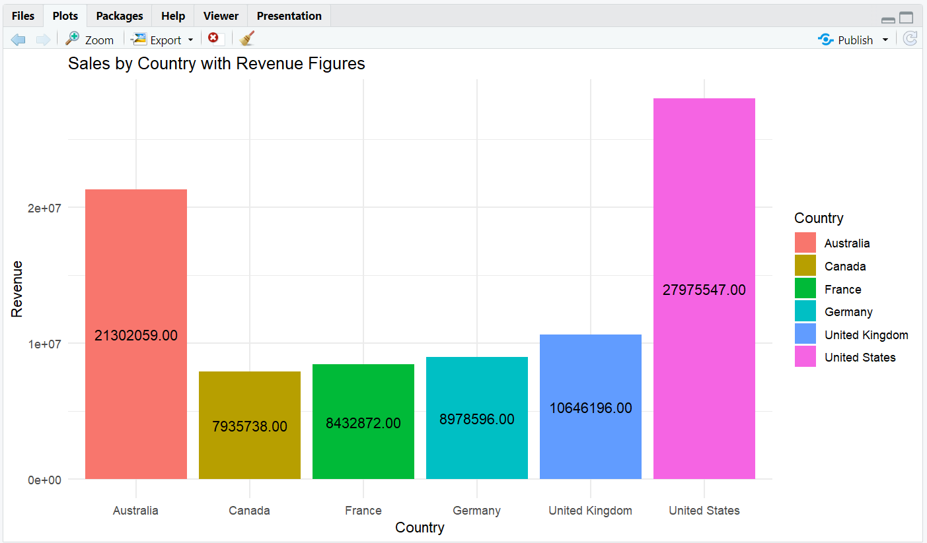

The above bar graph illustrates that the majority of the revenue comes from United states and Australia and the countries like Canada, France, Germany and united kingdom have comparatively lower revenue so we can focus on these regions more in order to increase the revenue.

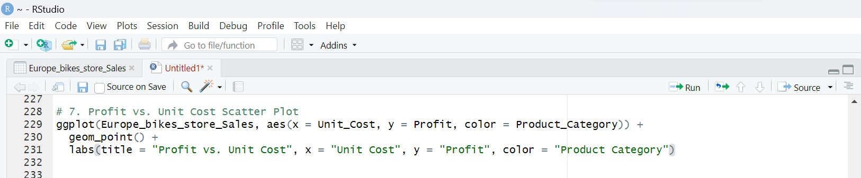
The above code helps us to visualise profit and cost of a unit.

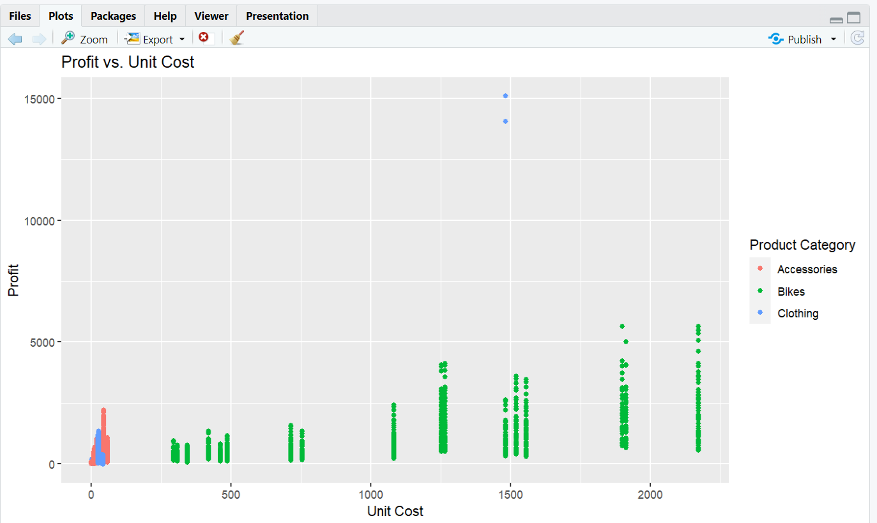

In the above graph we can see that in the clothing category near 1500 cost price the profit is very high compared to other categories, we can manufacture and promote the more to increase the sale of that particular product in order to maximise the profit.

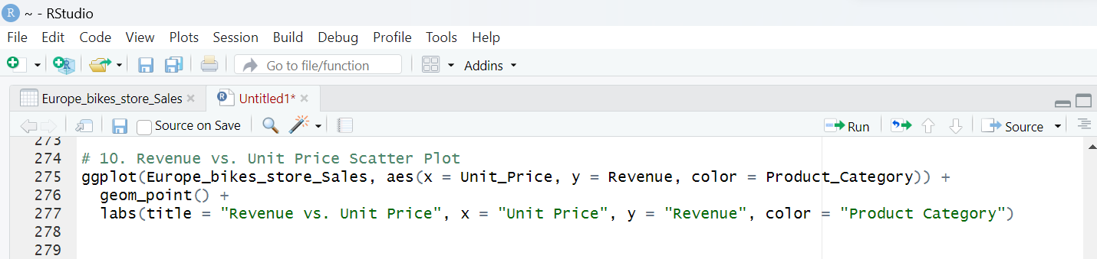
The above code helps us to visualise the revenue and price of a unit

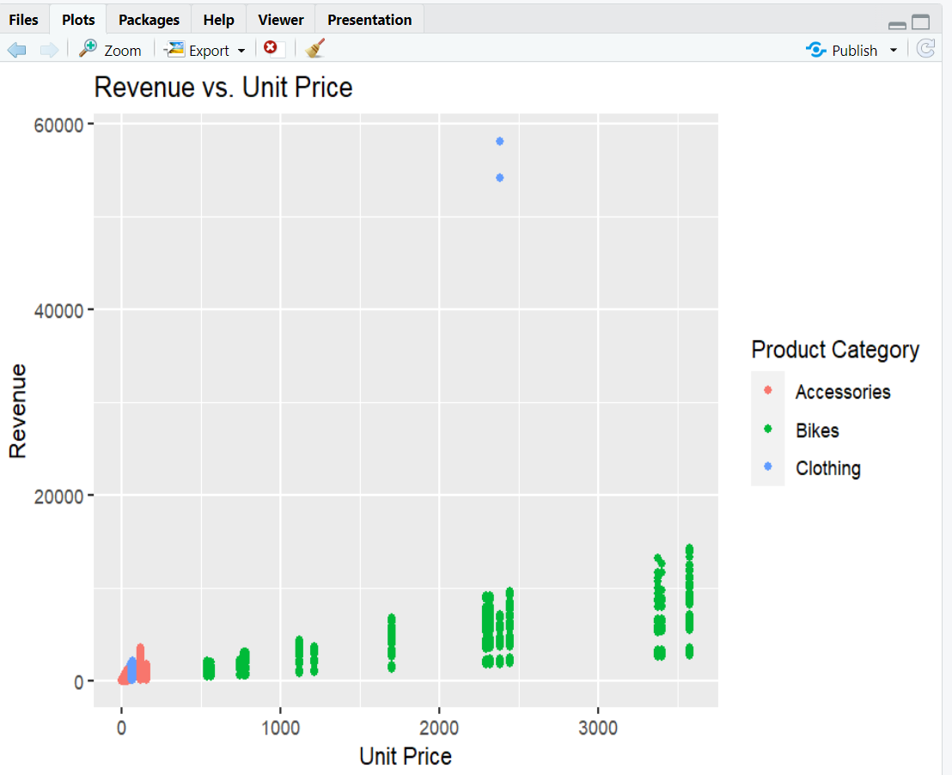

From the above graph we can get insight that as the cost price increases the revenue of the product also increases. So based on this insight we can increase the production and promotion of the high-end products so we can increase the profit of the organisation.

Results

The yearly sales trends and profit margin analysis in the graphs that are provided offer insightful information for strategic corporate decision-making; however, careful and complex evaluation is necessary for successful application. Australia's sales dropped from 28.5 in 2015 to 20.3 in 2016, indicating that the country's market needs more attention. But reducing this to a shortage of promotions alone is to oversimplify the reality. According to Kumar and Reinartz (2018), external influences like as shifts in consumer preferences and economic fluctuations can have a significant impact. Before launching pricey advertising initiatives, a careful examination of these variables is essential. Although bikes have the lowest average profit margin of any product category, as shown by the graphs, a decrease in product costs should be undertaken with caution. Cost-cutting measures taken carelessly could result in a drop in consumer loyalty and brand reputation as well as a reduction in product quality (Kumar & Reinartz, 2018). The age distribution graph reveals that a large proportion of customers are in the 20–35 age range, which could be a target market for marketing initiatives. But focusing only on this group leaves out other potentially important ones. Greater returns could be obtained from a more comprehensive strategy that takes into account customer lifetime value and brand affinity across age groups. These insights provide helpful guidance for strategic planning, but for well-informed decision-making and long-term business growth, an in-depth knowledge of contextual elements, potential hazards, and varied consumer segments is necessary.

Conclusion

The Kaggle Europe Bike Store Sales dataset provides insightful information on consumer segments, profitability, and sales patterns. The analysis reveals a notable decline in Australian sales in 2016, indicating a need for focused approaches. Bikes have the lowest profit margin, highlighting the significance of cost minimization. The gender turnout indicates a slight male majority, while the age distribution points to a concentrate on the 20–35 age range. The dataset emphasizes the importance of Australia and the United States in terms of revenue. By using this data, marketing targeting, cost control, and promotional activities may all be strategically planned to increase total profitability.

PROFESSIONAL, ETHICAL AND LEGAL CONSIDERSATIONS

When working with the Europe Bike Store Sales dataset from Kaggle, it is necessary to be aware of such issues as professional, ethical and legal considerations. Professionals need to ensure responsible data handling, meaning protecting customer privacy and complying with legal regulations governing consumer information. It is ethical to accurately represent findings and not interpret these in a biased manner that can affect business decisions. It is important for the methods of data collection being used by companies to be transparent so that trust can always form between businesses and consumers. Moreover, adhering to legal standards like GDPR and other regional data protection laws helps protect individuals’ rights. There is a need to find the balance between data-driven insights and ethics in business analytics’ ethical use of date.

Future work
Future work based on the Europe Bike Store Sales dataset may use machine learning systems to apply predictive analytics for precise prediction of sales. Targeted marketing methods would also be made possible by investigating improved client segmentation through the use of clustering techniques. Localized marketing activities can be guided by the use of Geographic Information System (GIS) tools, which can reveal area sales patterns. Predictive power is increased by incorporating external factors such as economic data. Finally, sentiment analysis using Natural Language Processing (NLP) on customer evaluations provides qualitative information for improving engagement tactics and products. This multipronged strategy guarantees a thorough comprehension and enables companies to make wise choices for long-term growth and market adaptability.

References

Brea, C. (2014). Marketing and Sales Analytics: Proven Techniques and Powerful Applications from Industry Leaders. Pearson Education, Limited.
Chang, W., Cheng, J., Allaire, J., Xie, Y., & McPherson, J. (2021). shiny: Web application framework for R [Computer software]. URL https://CRAN. R-project. org/package= shiny (R package version 1.6. 0).
Chen, H., Chiang, R., & Storey, V. (2012). Business Intelligence and Analytics: From Big Data to Big Impact. MIS quarterly, 36(4), 1165-1188. https://doi.org/10.2307/41703503
Dasu, T., & Johnson, T. (2003). Exploratory data mining and data cleaning. John Wiley & Sons.
Fader, P., Hardie, B., & Lee, K. (2015). "Counting Your Customers" the Easy Way: An Alternative to the Pareto/NBD Model. Marketing science (Providence, R.I.), 24(2), 275-284. https://doi.org/10.1287/mksc.1040.0098
Fergurson, J. R. (2020). Data-driven decision making via sales analytics: introduction to the special issue. Journal of marketing analytics, 8(3), 125-126. https://doi.org/10.1057/s41270-020-00088-2
Habel, J., Alavi, S., & Heinitz, N. (2023). Effective Implementation of Predictive Sales Analytics. Journal of marketing research. https://doi.org/10.1177/00222437221151039
Kuhn, M. (2008). Building predictive models in R using the caret package. Journal of statistical software, 28, 1-26.
Kumar, V., & Reinartz, W. (2018). Customer relationship management. Springer.
Verhoef, P., Kannan, P., & Inman, J. (2015). From Multi-Channel Retailing to Omni-Channel Retailing. Introduction to the Special Issue on Multi-Channel Retailing. Journal of retailing, 91(2), 174-181. https://doi.org/10.1016/j.jretai.2015.02.005
Wickham, H. (2016). Data analysis. Springer.
Wickham, H., & Grolemund, G. (2017). R for Data Science: Import, Tidy, Transform, Visualize, and Model Data. O'Reilly Media, Incorporated.
Xie, Y. (2017). Dynamic Documents with R and knitr. CRC Press.

